Expense Report Training Manual

Logging In 3
Expense Report Creation & Processing 4
Creating an Expense Report 4
Purpose tab 5
Locations tab 7
Default Charges 9
Adding expenses onto an Expense Report 11
Adding Expenses 13
Airfare Expenses: Details tab 14
Airfare Expenses: Amount tab 15
Airfare Expenses: Charge Allocation tab 16
Lodging Expenses: Details tab 16
Lodging Expenses: Amount tab 18
Lodging Expenses – Charge Allocations tab 19
Meal Expenses – Details tab 19
Meal Expenses – Meal Details tab 20
Meal Expense – Charge Allocations tab 21
Submitting your Expense Report 22
Attaching receipts 23
Adding Attachments: 23
Viewing, Modifying, or Deleting Attachments: 24

Logging In

The Login screen looks like this:
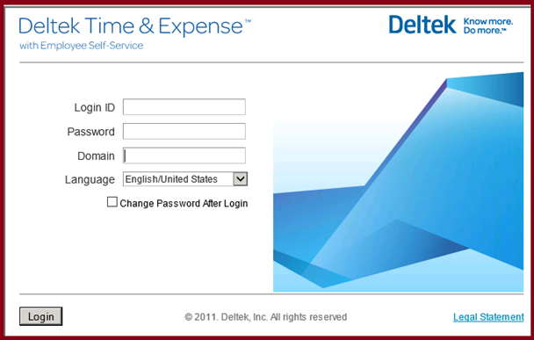
You will need to log in to the Time and Expense system using the same credentials (Login ID, Password, and Domain) that you use when you fill out your timesheet.
If you cannot remember your Login ID, your Password, or the Domain, please contact your system administrator.

Expense Report Creation & Processing

This document will cover:
- How to create a new expense report
- How to add expenses onto an expense report
- How to submit an expense report for approval
- How to attach your receipts to an expense report

Creating an Expense Report

To access the Expense Report system, go to:

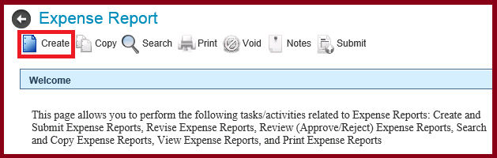
Expense >> Record Expenses >> Expense Report

To create a new expense report, press the Create button located at the top, left side of the screen.

You will need to potentially fill out three tabs:
- The Purpose tab, which identifies the dates of the expenses as well as the reason why you have these expenses;
- The Locations tab, which identifies the places that traveled to;
  - NOTE: The location tab is used only for those expense reports that require a location.
- The Charge Defaults tab, which identifies the project(s) that should be charged.

Purpose tab
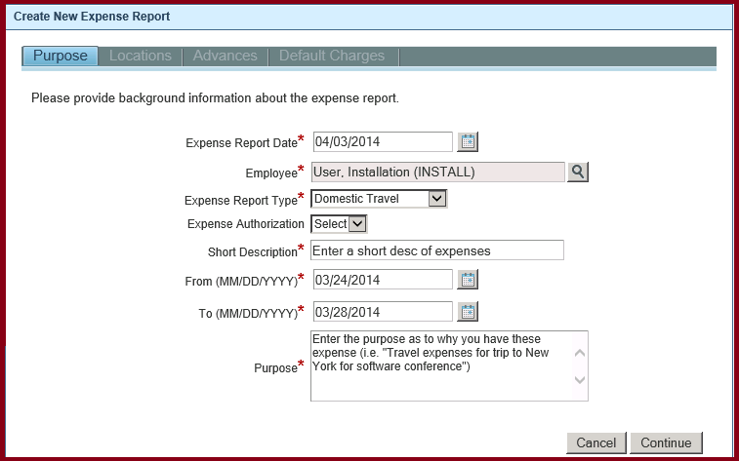
The following information is displayed on the Purpose tab:
- Expense Report Date:
  - This is the date that the expense report was created. It defaults to today’s date for a new expense report.

- Employee:
  - This is the person for whom the expense report is for.
  - If you are a supervisor, you can click on the magnifying glass () icon in order to fill out an expense report on behalf of one of your employees.
  - It defaults to your name.

- Expense Report Type:
  - You must select the type of expense report that you are going to fill out. The type of expense report that you select will determine other additional information that wil be required.

- Expense Authorization:
  - This field will be displayed if the type of expense report that you selected requires an expense authorization. If it is displayed, select the expense authorization that you filled out prior to incurring these expenses.
  - The system will default certain information onto the expense report based on the expense authorization that you selected. That information includes:
    - Expense Report Dates (Starting and Ending)
    - Purpose
    - Location(s)
    - Charge Allocations
  - You can modify or add to the information that was defaulted based on the authorization as needed.

- Short Description:
  - Enter a short description as to the reason why you have these expenses.

- From/To Dates:
  - Enter the starting and ending dates of the expenses that you will be adding to your expense report.

- Purpose:
  - Enter the purpose of this trip. This is typically a longer description of the trip than what you entered in the “Short Description” field.

Press the “Continue” button to move to the Locations tab.

Locations tab
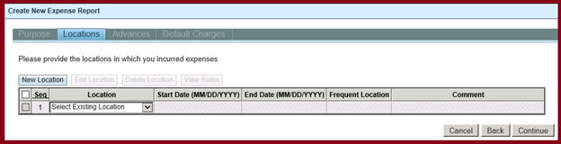
The Locations tab is used to identify the places in which you traveled. These locations are used to calculate Per Diem meal and lodging amounts.

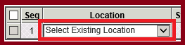
If you have entered an expense report in the past and already filled out a location and marked it as a ‘Frequent’ location, that location will appear in the ‘Select Existing Location’ dropdown.
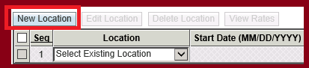
To enter a new location, press the “New Location” button.

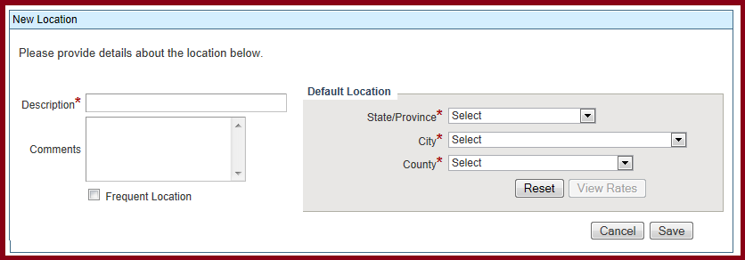
The following information is required:
- Description:
  - The Description will default based on the Country, State, and City that you select from the drop down on the right. You can override this description of the location if you choose.

- Country, State, City, County:
  - This information is pulled from the Per Diem files that are put out by the US Government.

  - The options that you have to pick from (i.e. Country, State, City, etc.) are based on the type of expense report that you selected (for example, a “Domestic Travel” Report will not use the “Country” field since all locations are in the United States.)

  - The Per Diem rates are based on the location that you select.

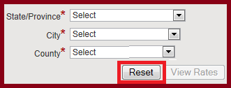
  - To clear out a location, press the ‘Reset’ button.

- Comments:
Enter any comments regarding this location. This is an optional field.

- Frequent Location:
  - If you plan on submitting many expense reports to the same location, check the “Frequent Location” checkbox. This will add this location to your list of existing locations for ease of entry, and will display in the “Select Existing Location” dropdown.
Press Save to continue.

Enter all locations that you traveled to for the expenses on this expense report.
When finished, press the “Continue” button to move to the Default Charges tab.

Default Charges
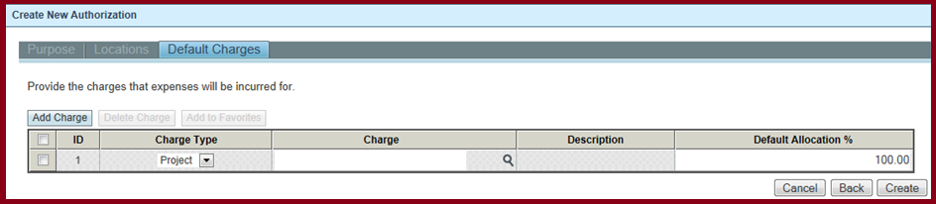
The Default Charges tab is used to identify the project or projects that should be charged for these expenses.

You can enter one or more projects on this screen. The Default Allocation percentage is used throughout the expense report to split costs between projects. This percentage can be changed on an expense-by-expense basis.
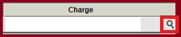
To enter the first project, use the magnifying glass icon located in the center of the screen.

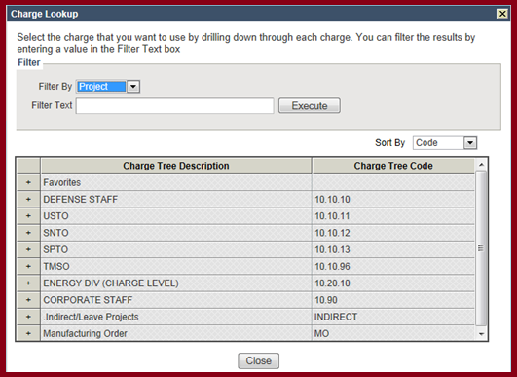
The Charge Lookup is the same lookup that you use to enter charges onto your timesheet. Follow the same procedure to find the project(s) that should be charged on your expense report that you do when you look up charges on your timesheet.

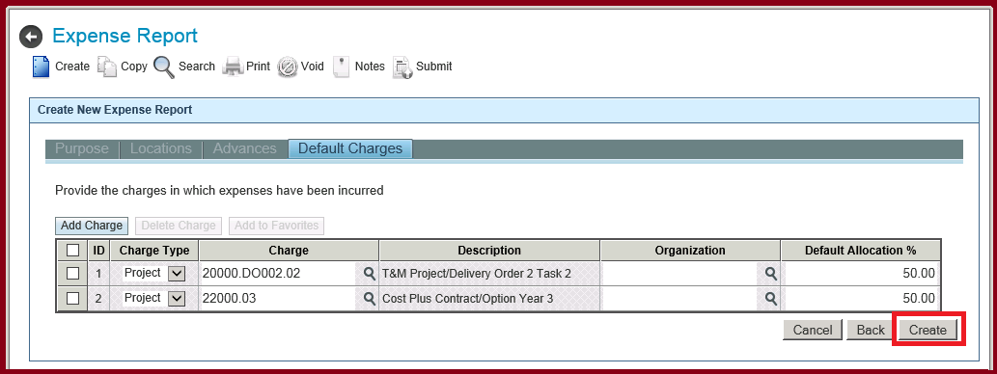
When you have finished entering your project(s), press the “Create” button to create this expense report. It is now saved. You can complete it now or come back at a later time and finish it.

Adding expenses onto an Expense Report
You should add all of the expenses in which you want to be reimbursed onto this expense report.

To add these expenses, go to the “Claimed Expenses” section of the expense report. (The system should take you directly there once you press the “Create” button)
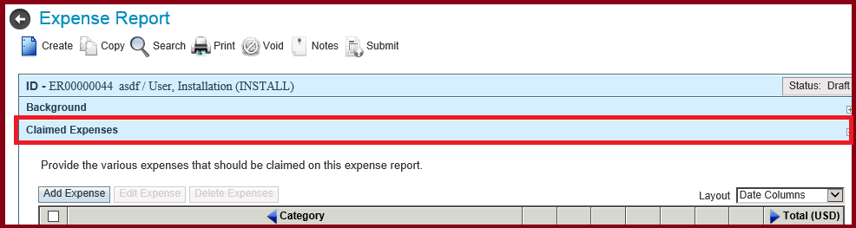

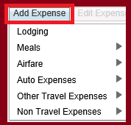
Press the “Add Expense” button.
A list of Categories will be displayed. Some Categories have ‘sub’ categories which means there are additional options for that category of expenses.
Using your mouse, hover over the category. If there are NO ‘sub’ categories, there will NOT be a black triangle to the right. You can select that Category. Otherwise, the list of ‘sub’ categories will be displayed when you hover over the category.

Adding Expenses
These instructions will go over how to add specific expenses.
All expenses have the same basic requirements – there is a “Details” tab, an “Amount” tab, and a “Charge Allocations” tab. All tabs have required information that must be filled out. In addition to this information, some expenses require additional information that will appear on different tabs.

Airfare Expenses: Details tab
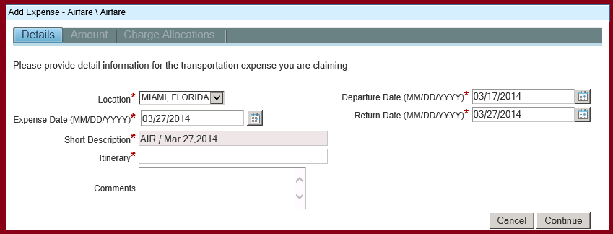
The following information is required:
- Location:
  - Select the location from the drop-down. The list available is based on the locations that you entered at the beginning of the expense report.
  - Note: a Location is only required if Locations are required for the type of expense report that you selected.

- Expense Date:
  - Enter or Lookup the date of this expense. It will default to the End date that was entered at the beginning of the expense report.

- Short Description:
  - This is a system calculated field and cannot be changed.

- Departure/Return Dates:
  - The system will default the Departure and Return dates based on the dates you entered on the overall expense report. You can change them if necessary.

- Itinerary:
  - Enter the Starting and Ending locations of your airline ticket
  - Note: Itinerary is only required if it has been configured to be required.

Press “Continue” to go to the Amount tab

Airfare Expenses: Amount tab
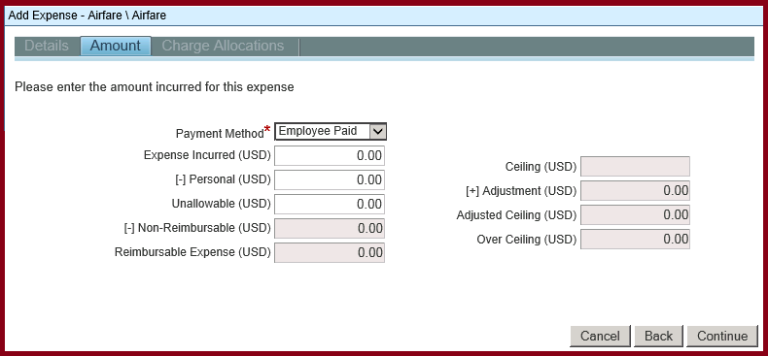
The following information is required:
- Payment Method:
  - Select the way in which you paid for this airfare expense.
  - The system will default the Payment Method to “Employee Paid”.

- Expense Incurred:
  - Enter the amount that you paid for this airfare expense.

- Personal:
  - Enter any Personal amounts
  - Note: Personal amounts are NOT reimbursed to you.

- Unallowable:
  - Enter any amount that is deemed unallowable by FAR regulations.
  - For example, upgrade fees (from Economy class to Business class) are considered an ‘Unallowable’ expense.
Press “Continue” to go to the Charge Allocations tab.

Airfare Expenses: Charge Allocation tab
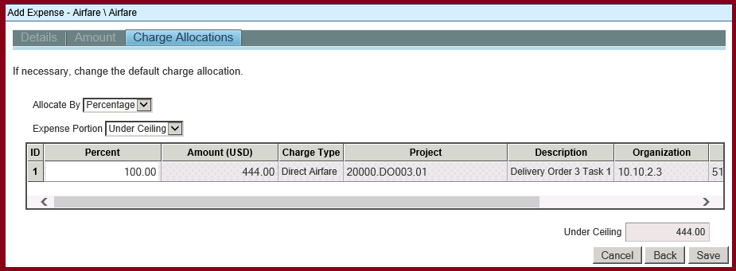
This tab is used to allocate the expense amounts to the projects that were entered when you first filled out the expense report
If you only entered one project, this screen is display only. If you entered two or more projects, you can override the default allocation percentage for the airfare expense by changing the percentage.
Press “Save” to save this expense.

Lodging Expenses: Details tab
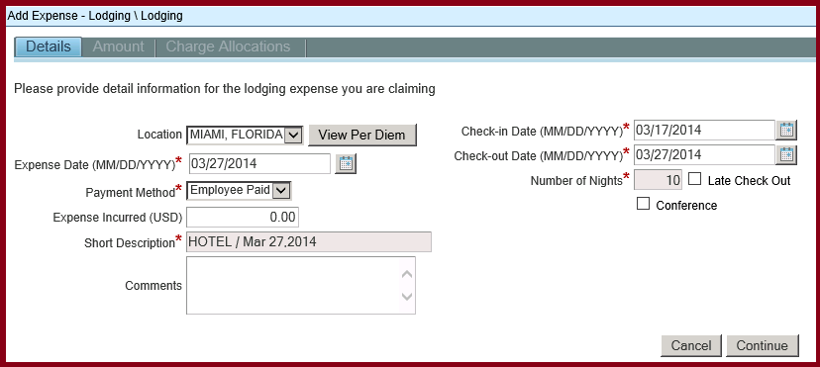
The following information is required:
- Location:
  - Select the location from the drop-down. The list available is based on the locations that you entered at the beginning of the expense report.
  - Note: a Location is only required if Locations are required for the type of expense report that you selected.

- View Per Diem button:
  - You can view the Per Diem amounts for the location that you selected by pressing the “View Per Diem” button. It will show both the Meals and the Lodging Per Diem amounts.

- Expense Date:
  - Enter or Lookup the date of this expense. It will default to the End Date that was entered at the beginning of the expense report.

- Payment Method:
  - Select the way in which you paid for this lodging expense.
  - The system will default the Payment Method to “Employee Paid”.

- Expense Incurred:
  - Enter the amount that you paid for this lodging expense.

- Short Description:
  - This is a system calculated field and cannot be changed.

- Check In / Check Out Dates:
  - Enter or Lookup the check in and check out for this lodging expense.
  - The dates entered will determine the Per Diem rate.
  - The system will default the dates based on the dates entered at the beginning of the expense report.

Press “Continue” to go to the Amount tab.

Lodging Expenses: Amount tab
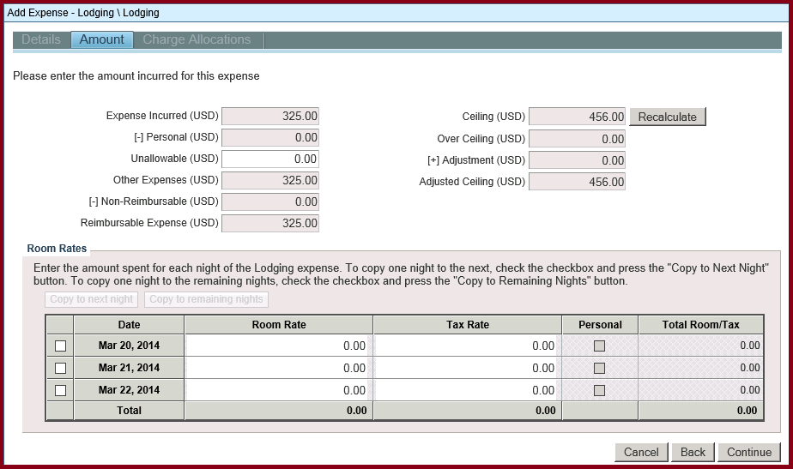
The system will default the amount that you entered on the Details tab into the “Expense Incurred” field on the Amount tab.
You must break out the amount spent on a PER NIGHT basis for the room rate and tax rate. This will allow the system to correctly calculate the Per Diem amount so you are reimbursed correctly.
If the same rate is used for all nights, you can copy the rate down to the remaining nights by checking the checkbox next to the row and pressing either the ‘Copy to next night’ or the ‘Copy to remaining nights’ buttons.
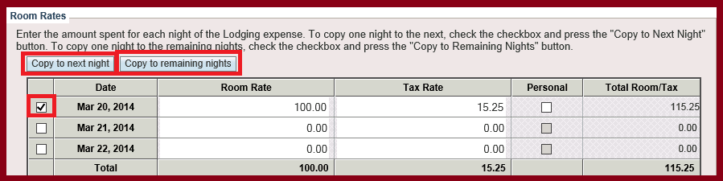
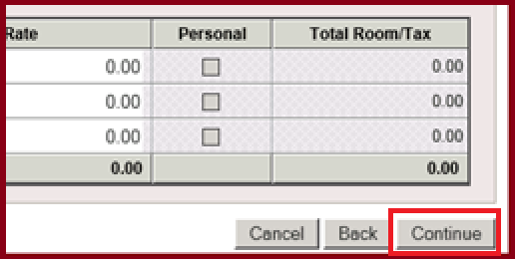
Press the “Continue” button when finished.

Lodging Expenses – Charge Allocations tab
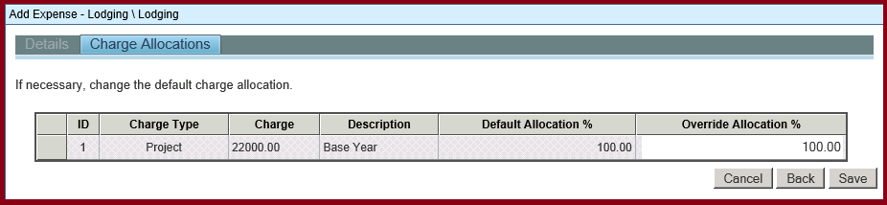
This tab is used to allocate the expenses to the projects that were entered when you first filled out the expense report
If you only entered one project, this screen is display only. If you entered two or more projects, you can override the default allocation percentage for the airfare expense by changing the percentage.
Press “Save” to save this expense.

Meal Expenses – Details tab
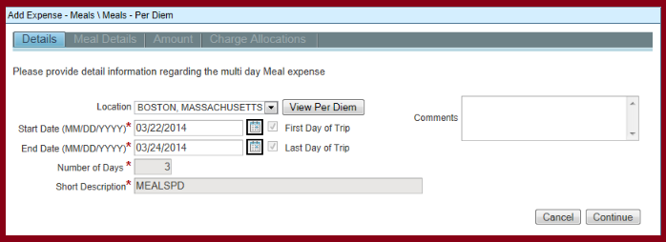
The following information is required:
- Location:
  - Select the location from the drop-down. The list available is based on the locations that you entered at the beginning of the expense report.
  - Note: a Location is only required if Locations are required for the type of expense report that you selected

- View Per Diem button:
You can view the Per Diem amounts for the location that you selected by pressing the “View Per Diem” button. It will show both the Meals and the Lodging Per Diem amounts.

- Start and End Dates:
  - Enter or Lookup the starting and ending dates of this expense. The system will default the dates based on the dates entered at the beginning of the expense report.

- Number of Days:
  - This is a system generated number that calculates the number of days by subtracting the start date from the end date. You cannot change this number.

- Short Description:
This is a system calculated field and cannot be changed.

Press “Continue” to go to the Meal Details tab

Meal Expenses – Meal Details tab
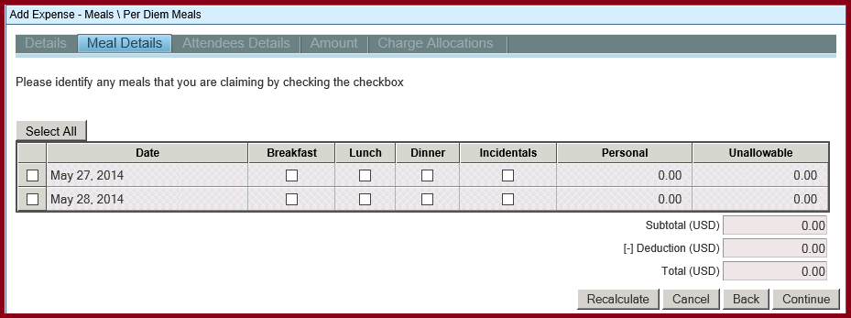
You must identify all meals that you are claiming by checking the checkbox for the meal and the day.
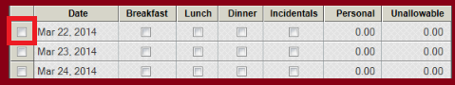
Any meals in which someone else paid for you (for example, if someone took you out for a lunch or a dinner and you DID NOT PAY, you must not claim that meal.
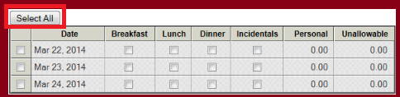
You can claim all meals for a given day by checking the checkbox on the left side of the screen.
You can claim all meals for all days by pressing the ‘Select All’ button.

Press the “Continue” button to go to the Charge Allocation screen.

Meal Expense – Charge Allocations tab
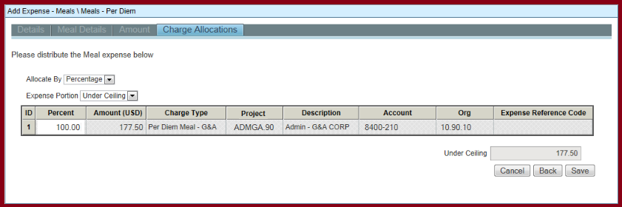
The system will calculate the reimbursement amount based on the location that you selected as well as the checkboxes that you checked.
Note: you will be reimbursed 75% for the first day and 75% for the last day based on FAR regulations.
Press “Save” to save this expense.

Submitting your Expense Report
Once you have entered all of your expenses onto you expense report, you must submit it in order for it to be approved and processed through for payment.

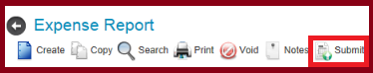
To submit your expense report, press the “Submit” link at the top of the screen.

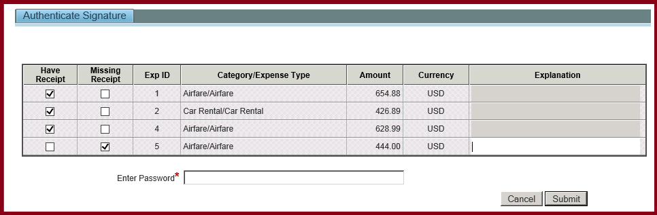
You must identify whether or not you have the hard copies of the receipts. These hard copies must be turned in to accounting before you will be paid for this expense report.
Any receipts that are missing require an explanation.
To submit your expense report, enter your password. This is the same password that you used to access the Time & Expense system. Press the “Submit” button when finished.

Attaching receipts

Once you have submitted your expense report, you must attach any required receipts.
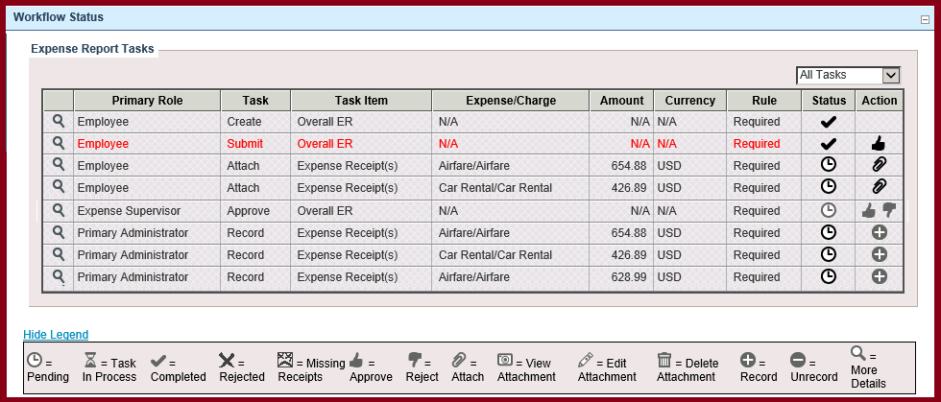
To attach a receipt, press the paperclip icon located in the Workflow Status component of the expense report:
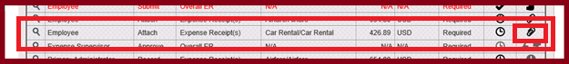

Adding Attachments:
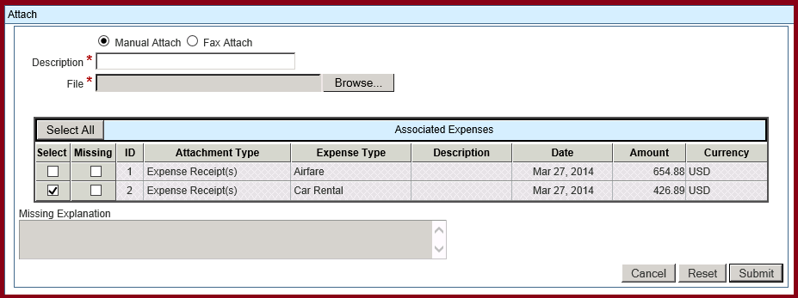
- Description:
  - Enter a description for this attachment.
  - Suggestions include “Receipts for Project ABC trip”, “Receipts”, etc.
- File:
  - Using the Browse button, find the file on your computer that contains the receipts.

- Associated Expenses section:
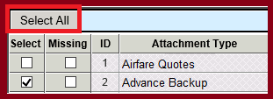
  - Since you can include more than one receipt in a file, you must identify which expenses are included in that file. You can select all expenses by pressing the “Select All” button.

  - If any of your receipts are missing, you must check the Missing checkbox and enter an explanation as to why they are missing:
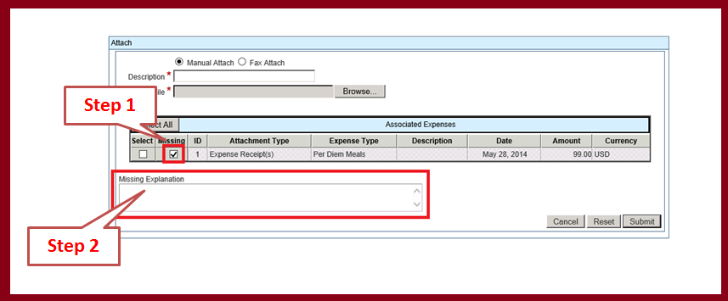

Note: A hard copy of the expense report, with receipts, must also be submitted to Accounting in Suite 102.

Press Submit when you have finish.

Viewing, Modifying, or Deleting Attachments:
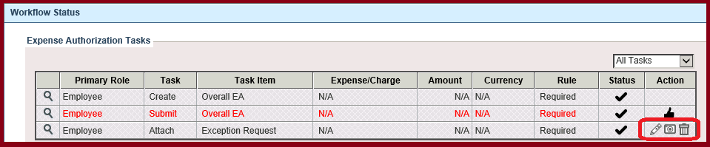
You can view, modify, or delete any attachments that have been entered on an expense report by pressing one of three links:
Edit: You can edit the Description or the linked expenses that are tied to this attachment by pressing this link.

View: You can view the attachment by pressing this link.

Delete: You can delete this attachment by pressing this link.

