**Website:** <https://www.paylocity.com/>

Once in Paylocity, click on ‘Login’:

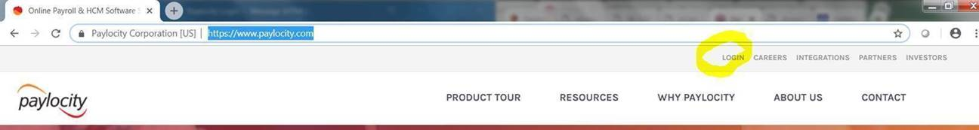

You will be asked for the company code (**80490**) and to create your login and password.

Once you are logged into Paylocity, Click on the Self Service portal in the far left corner

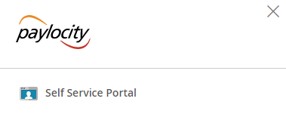

Your paychecks and Payroll information is located in the middle area of the Self Service portal. You can make changes to your direct deposit or tax exemptions in this section:

