Timekeeping – Entering Time for Salaried Employees
Log in to Deltek timekeeping
https://teprod.pfenex.com/DeltekTC/welcome.msv
Go to current week’s timesheet.
- This can be done via the Home screen by clicking the link under the MyTimesheets section
- Or by Time > Record Time > Timesheet
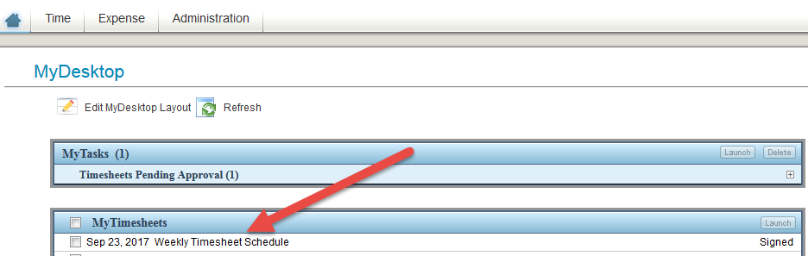
-or-
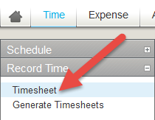
*Make sure you are in the correct period ending week*
Under Project, use magnifying glass to search for proper coding
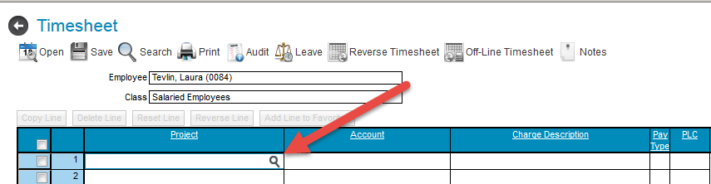
Select project by selecting the ‘+’ sign of the appropriate ‘Charge Tree Description’
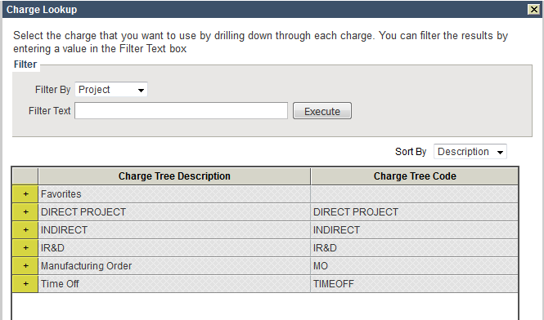
Charge Tree Description Examples:
- Favorites – you can add your personal favorites after you select project for the first time
- Direct Project examples:
  - BARDA
  - NIAID
  - PATH
  - Serum CRM197
- Indirect (Admin) examples:
  - Business Development
  - Corporate General Support
  - Facilities
  - Finance & Accounting
  - HR – General
  - IT – General
- IR&D examples:
  - See ‘Cheat Sheet’ for Generic R&D codes for R&D related items not associated with a project. Quality related items fall under this.
  - 529 LA (lab) or NL (non-lab)
  - 530 LA (lab) or NL (non-lab)
  - 582 LA (lab) or NL (non-lab)
  - 708 LA (lab) or NL (non-lab)
  - 743 LA (lab) or NL (non-lab)
- Time Off
  - Paid Time Off
    - Bereavement (up to 3 days)
    - Family Sick (40 hours per year)
    - Holiday
    - Sick
    - Vacation
  - Unpaid Time Off
Select project (see direct manager for any questions on project code)
- Checkmark code
- Click ‘Add to Timesheet’
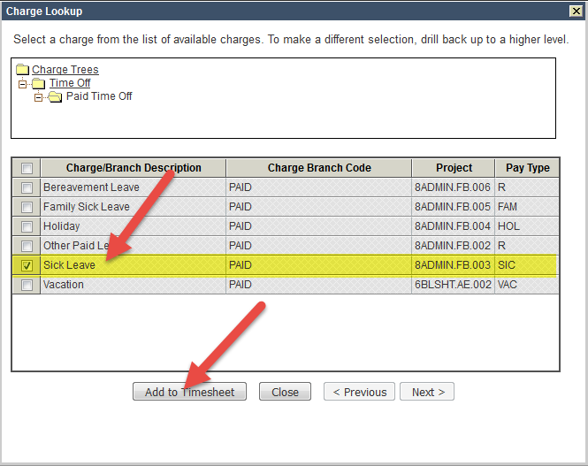
For codes used often, Checkmark the far left box on your timesheet and click ‘Add Line to Favorites’
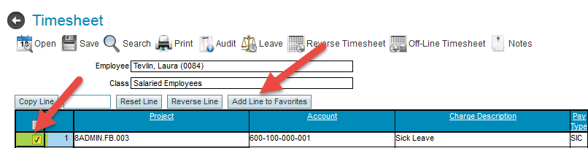
Once code is in Favorites, select Favorites + sign from magnifying glass, checkmark far left box, and click ‘Add to Timesheet’
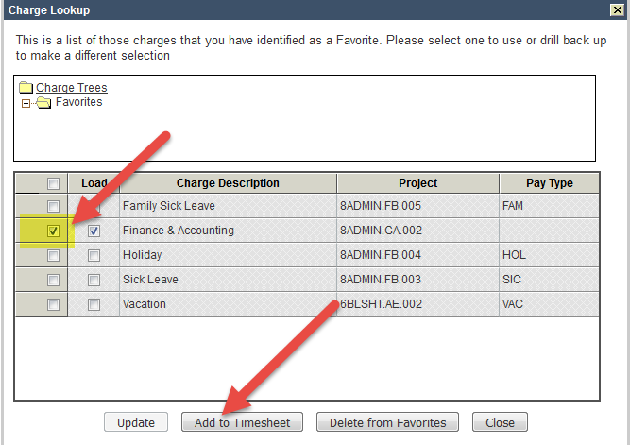
Fill in hours based on time and codes for each day
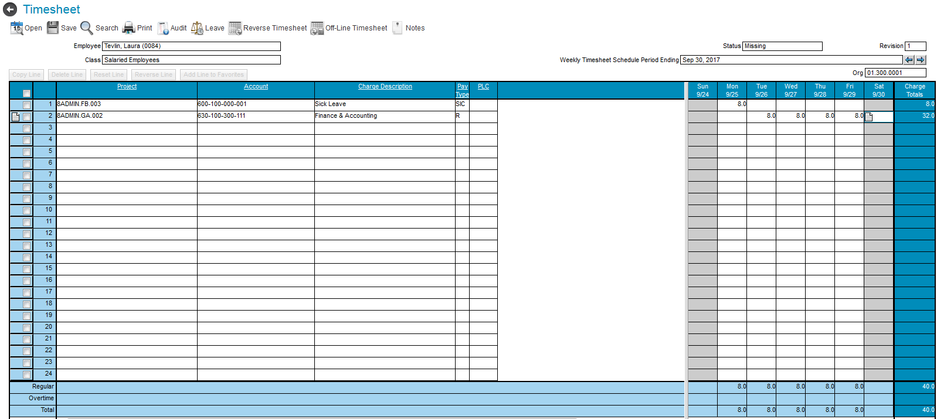
When hours are done for the day, click the Save button to save data.
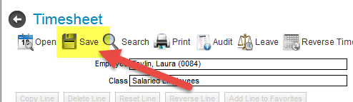
At the end of each week, your timesheet must be signed electronically.
Do this by clicking the icon by the signature box
A box will pop up for you to enter your password as signature confirmation.
You will know that your timesheet is signed when you see your name and employee number
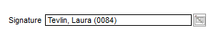
After this, your manager will need to approve your timesheet for it to be fully completed.

