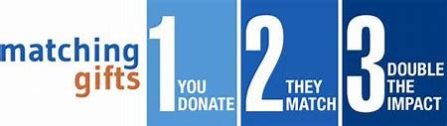
MATCHING GIFT REQUEST FORM
Help support your favorite charities and invite your colleagues! Pfenex will match 100%!

 | Donor Information
Donor Name:
Receipt/Proof of Donation and amount | Attach to form

Recipient Organization
Charitable Organization Name:
W-9 or EIN Number:
Street Address:
City/State/Zip:
Date of Gift:
Amount of Gift:

Certification Statement: I hereby certify that the information I have provided is complete and correct and that my gift hereby complies with the program provisions stated in the Matching Gifts Policy.

Donor Signature:
Date:

